Social media toolkit
National Catholic Health Care Week
The sixth annual National Catholic Health Care Week will take place from Sunday, February 2 to Saturday, February 8, 2025.
We are asking organizations across the country to recognize the Week through their social media platforms.
National Catholic Health Care Week is a Week to:
- Amplify our shared mission through a consistent, strong collective voice
- Showcase our role, value, and impact in local communities and across the country
- Demonstrate that we are people-centred, expert contributors to the health system
- Engage our stakeholders in conversation about Catholic health care
Why February?
National Catholic Health Care Week leads into The World Day of the Sick on February 11, a Catholic day of observance established by Pope John Paul II to encourage prayers and reflections for those who are ill and for all those who care for them.
Caring for our Common Home
Our 2025 theme celebrates the interconnectedness of all creation and helps us to reflect on how our individual and collective actions and our systems—health, social, economic—can promote a healthy world where all can thrive. It emphasizes the integral connection between human health and the health of the planet, echoing Pope Francis’ call to care for the earth as our common home (Laudato Si’). We work with many partners—in our Catholic community, our health system and beyond—to contribute to and help shape an ever-evolving health system, drawing on our Catholic values, and a legacy of innovation and ethical reflection. As Catholic health we are committed to environmental stewardship and conservation and actions to promote human flourishing. This week calls us to put the love at the heart of our ministry into action and inspires us to work towards environmental sustainability and human health and wellbeing in our homes, workplaces, communities and our world.
The Courageous Gift of Catholic Health Care
During National Catholic Health Care Week, we invite you to reflect on and share the story of the courageous gift of Catholic health care. As Catholic health organizations across Canada, we are united in a 400-year healing mission and are inspired by a calling to care for all with compassion and humanity—body, mind and spirit. We are driven to improve health care for all Canadians, especially those at greatest risk, as innovators, advocates and strong partners across our health care system. We are driven to make the world a better place, where everyone finds belonging, dignity and worth. In this, we reach out and take action with others to mend and bridge gaps, open doors and create the conditions for a society where all are seen and heard.
Social Media Posts and Hashtag
Please promote National Catholic Health Care Week on your social media platforms and use #catholichealthcareweek wherever possible during the Week.
We ask you participate in this important week of recognition for our teams and our mission. Daily branded National Catholic Health Care Week posts are provided—featuring one aspect of our commitment to caring for our common home. Recognizing the connection between a healthy environment and human health and wellbeing, these posts incorporate an image and message for you to build on. We encourage you to amplify this with examples of your own organization’s commitment to green initiatives and social justice/outreach efforts that support a healthy environment where all can thrive. Please use the hashtag #catholichealthcareweek. The link to National Health Care Week on the CHAC website is https://www.chac.ca/en/national-catholic-health-care-week/.
Posts are available here. Suggested topics for the types of stories (from the newsrooms of your own organization or in your community) that you may wish to share are also provided.
Day | Images  Download here | Sample post—or feature your own story/example | Ideas: possible examples/stories to share
February 2 to 8, 2025  Caring for our Common Home | 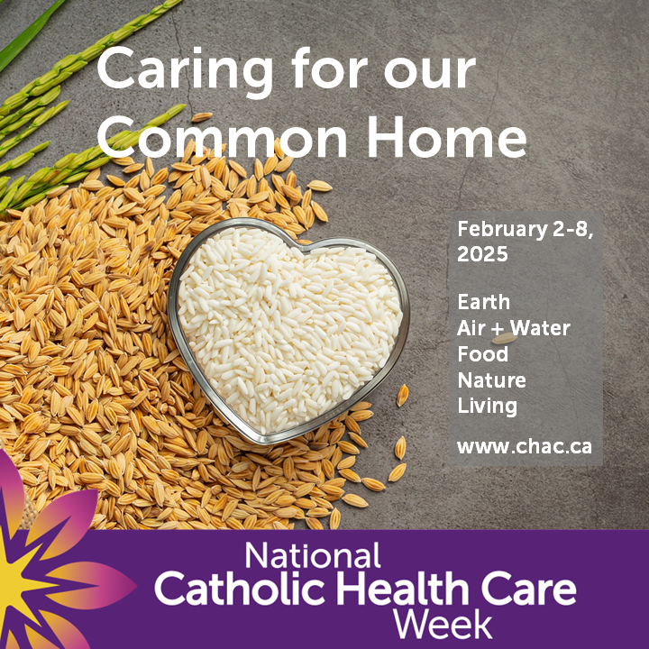  Download here | This National Catholic Health Care Week we celebrate the interconnectedness of all creation and reflect on the integral connection between human health and the health of the planet.  #catholichealthcareweek  NCHCW link: https://www.chac.ca/en/national-catholic-health-care-week/ | - Statement of organizational commitment to environmental stewardship/ sustainability  - If appropriate, membership in the Canadian Green Coalition for Health Care + link https://greenhealthcare.ca
Monday,  February 3  Earth | 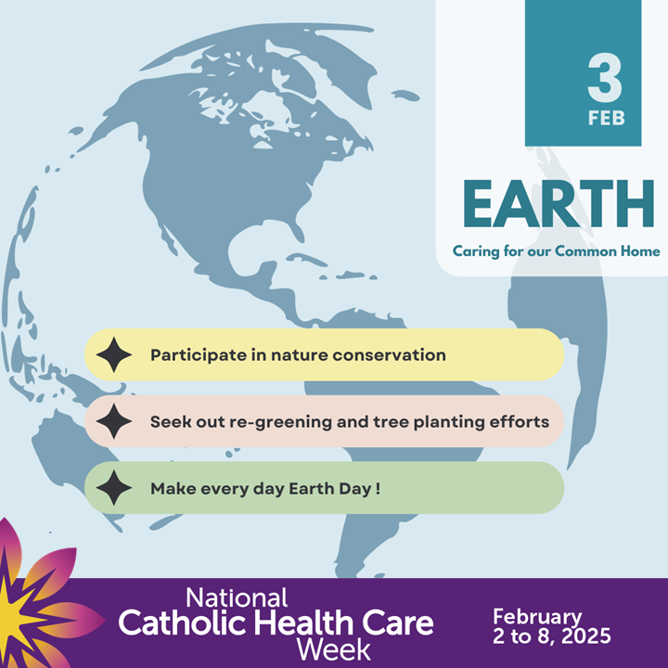  Download here | When we heal the earth, we heal ourselves. (David Orr)  We are children of the earth: people to whom the outdoors is home. Nothing can separate us from the vigour and vibrancy of this inheritance. (John O’Donahue)  #catholichealthcareweek  NCHCW link: https://www.chac.ca/en/national-catholic-health-care-week/ | - Patient, resident or team activities or efforts that celebrate earth as our home—Earth Day, harvest, seasons, art, outdoor features  - Integration of Indigenous teachings  - Innovative creative and sustainable uses of land
Tuesday,  February 4  Air and Water |   Download here | The magnificent interplay of the air we breathe, the water we drink and the land we live on gives all things life.  #catholichealthcareweek  NCHCW link: https://www.chac.ca/en/national-catholic-health-care-week/ | - Water conservation efforts—water systems, rain barrels, clean up  - Incorporation of outdoor/fresh air in activities or facility design  - Post-COVID improvements to air quality and safety
Wednesday, February 5  Food | 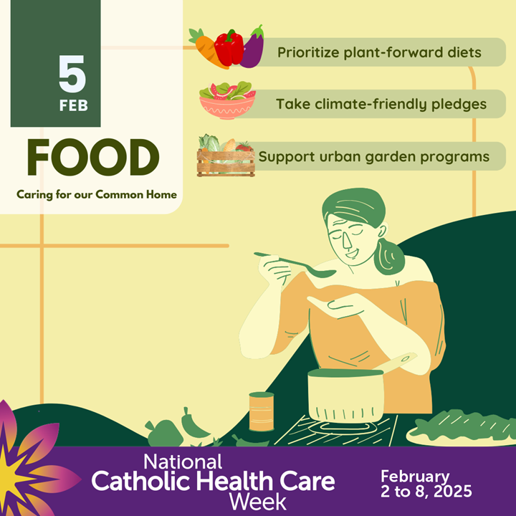  Download here | Bless the gardens of the world, the soil and rain and sunshine, and the work of all who sow and reap. Give abundant harvests, and teach us to share them with justice.  #catholichealthcareweek  NCHCW link: https://www.chac.ca/en/national-catholic-health-care-week/ | - Efforts to improve nutrition for patients, residents, staff community  - Food bank participation  - Production and consumption practices to reduce waste, share resources  - Food as therapy—growing food, food-related recreational activities
Thursday, February 6  Nature | 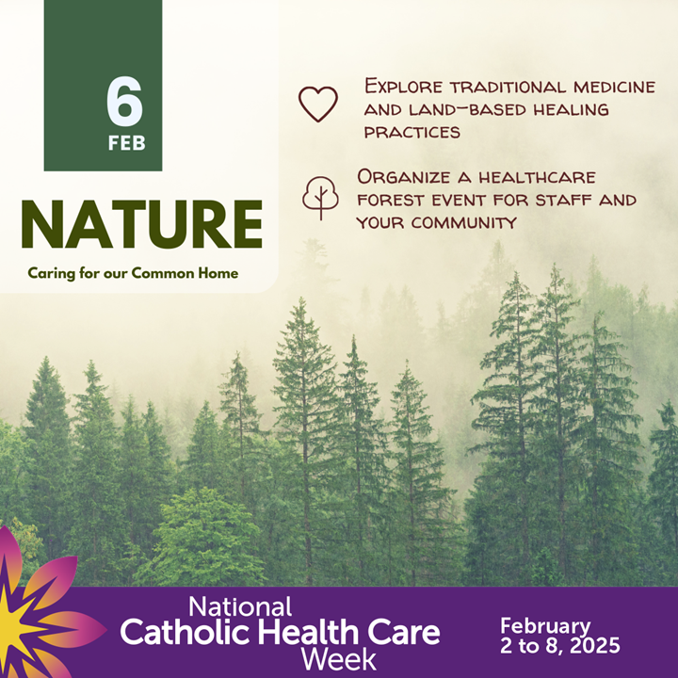  Download here | Spending time with nature centres us in our relationship with all living things and connects us to a bounty of gifts that foster health and wholeness—body, mind and soul  #catholichealthcareweek  NCHCW link: https://www.chac.ca/en/national-catholic-health-care-week/ | - Your own or shared efforts with community to improve biodiversity, preservation, conservation  - Tree planting or clean-up activities on your grounds  - Inclusion of healing gardens and green spaces  - Integration of Indigenous teachings and practices
Friday,  February 7  Green Living | 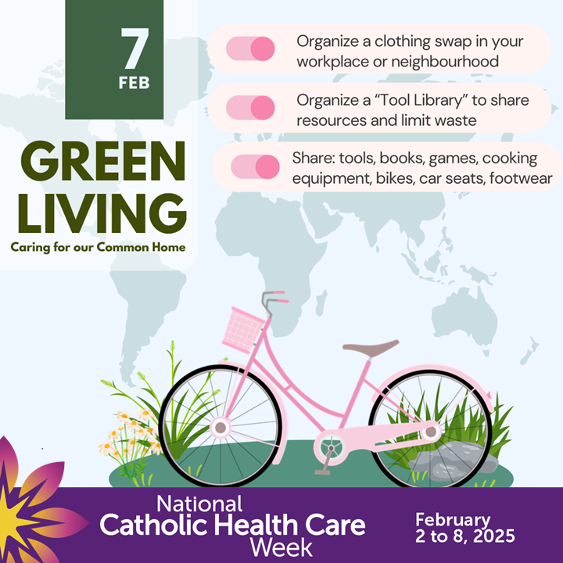  Download here | The choices we make each day impact our environment and the health and wellbeing of our human family around the globe. Let us be people of hope, believing our collective actions can build a world of justice and peace.  #catholichealthcareweek  NCHCW link: https://www.chac.ca/en/national-catholic-health-care-week/ | - Changes or improvements to systems or day to day operations to reduce, reuse, recycle  - Efforts to mobilize and influence change (ecology, social justice)  - Collaboration on community efforts—community gardens, food banks, preservation and clean up
Resources
Several resources are available on the CHAC website (chac.ca) including:
- A video on Catholic Health Care (less than three minutes)
- NCHCW 2025 Daily Reflections and Prayers
- NCHCW 2025 Key Messages and Resources
- The Courageous Gift and facts on Catholic health care in Canada
- National Catholic Health Care Week customizable template
Contact
John Ruetz
President and CEO, Catholic Health Alliance of Canada
e: john.ruetz@chac.ca • p: (613) 567-1200

